For the example.txt,it has 1080 instances , and each line is an instance.First all,you should call:
//gives your dataset's path and this function will build the internal data structures.
public static void loadData(String path) throws IOException;

This loads the data and builds the ball tree.

1.How to choose k
We run the algorithm iteratively from k=2 to k= 15.Each iteration we run the algorithm 20 times and find the one has least evaluation value.(We compute the sum of square of each instance’s distance to its clustering center as the evaluation of one run of the algorithm).We has the minimum evaluation value each iteration of k to be the y, and k to be the x.We do it serval times and we have those below.
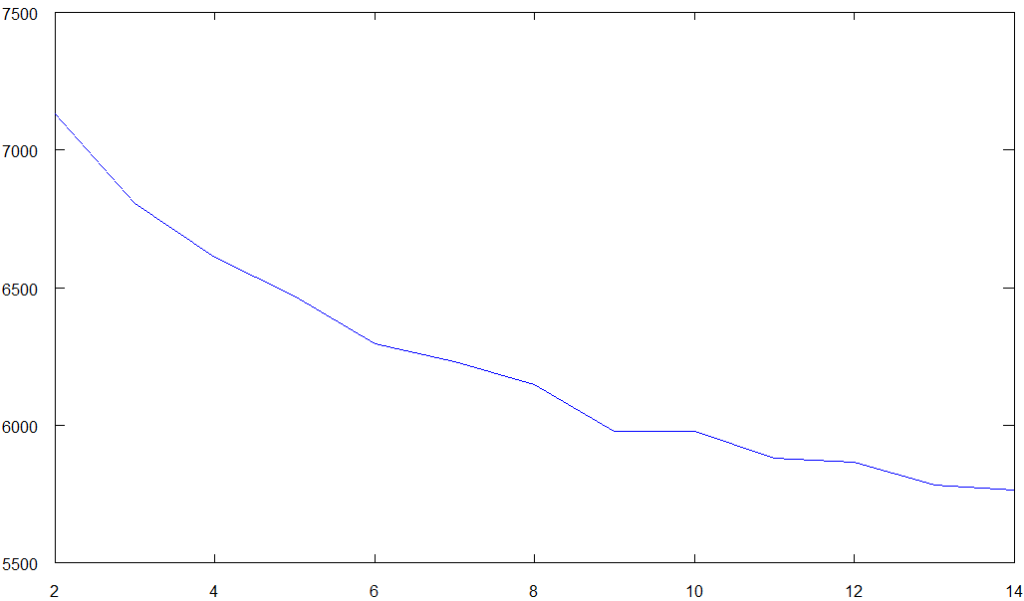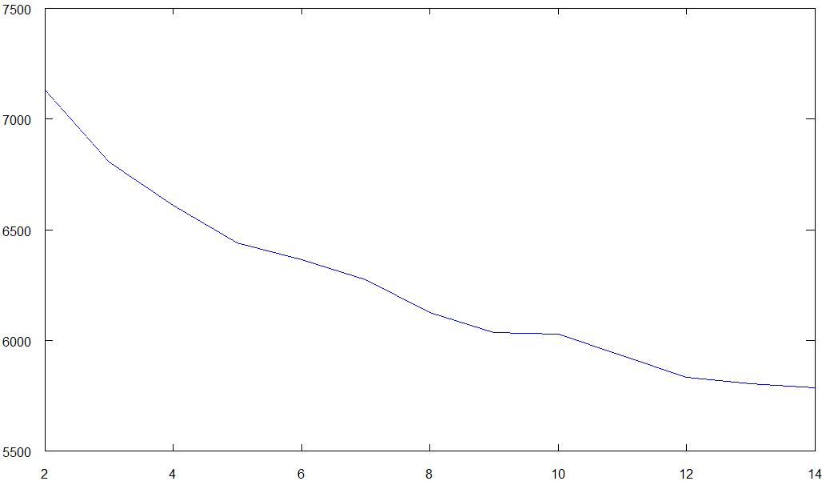
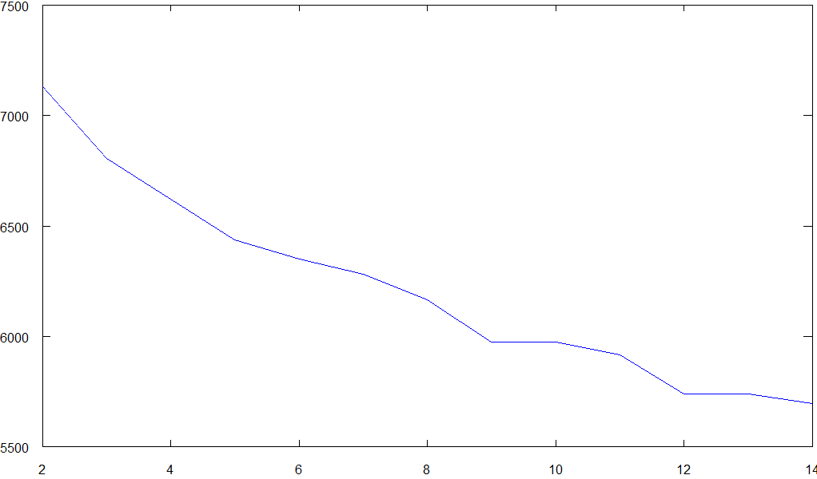
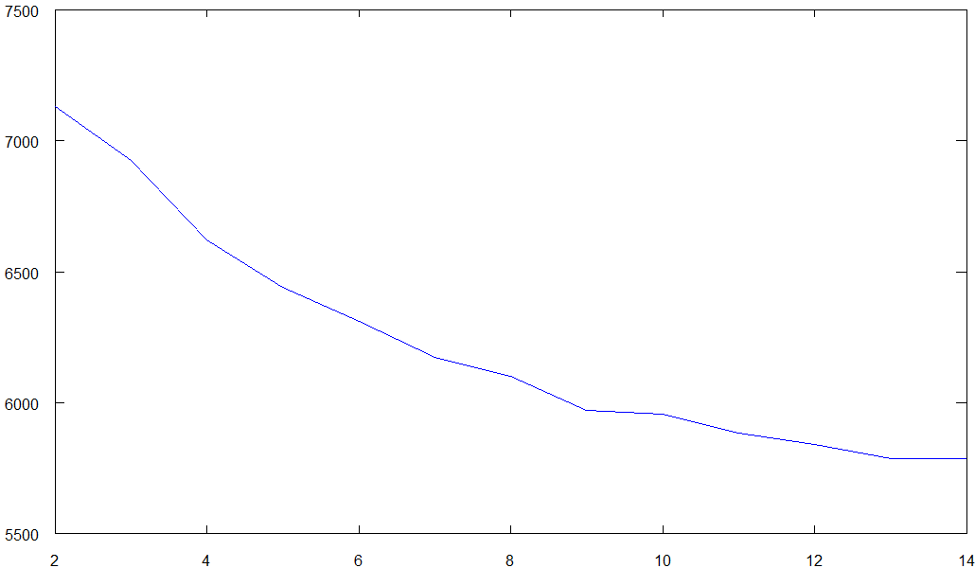

We can find that one thing is common.After k = 9,the tendency of downward is slowing down.And when k=9 and k = 10,it is almost flat.So it is like a pattern.After k = 9.the evaluation goes down slower and slower. It is better to be simple.So we choose k = 9.
This method is simple and weak.I am learning to apply some principles like MDL principle to automatically choose the k and make it more reasonable.

In the program,you can call in the Process file:
/**gives the evaluation and differential of each k in specific range.you can use these infos to choose a good k for your clustering
* @param startK gives the start point of k for the our try on k(inclusive)
* @param endK gives the end point(exclusive)
* @return Entry's key is the evaluation of clustering of each k.The value is the differential of the evaluations--evaluation of k(i) - evaluation of k(i+1) for i in range(startK, endK - 1)
* */
public static Entry<ArrayList<Double>, ArrayList<Double>> cluster(int startK, int endK);

- Then,we cluster.
We have k = 9.Then we call:
/**
* @param k the initial number of clustering centers
* @return an entry:the key is the result of clustering.The label starts from 0.The value is the evaluation of the clustering result
*/
public static Entry<Integer[], Double> cluster(int k);

In default, it will run the algorithm 10 times(you can change it in the conf.properties) to find the result with the minimum evaluation value.

Because I am a Chinese student, I have a blog with all the details in it written in Chinese.If you are interested in this and Chinese,you can read it at:http://blog.csdn.net/skyline0623/article/details/8154911

